Faith and Healthcare Forum
September 14, 2019

The Colombo Tactic – Caring for People Like Jesus
Kimo Thorpe, Plano Clinic Director

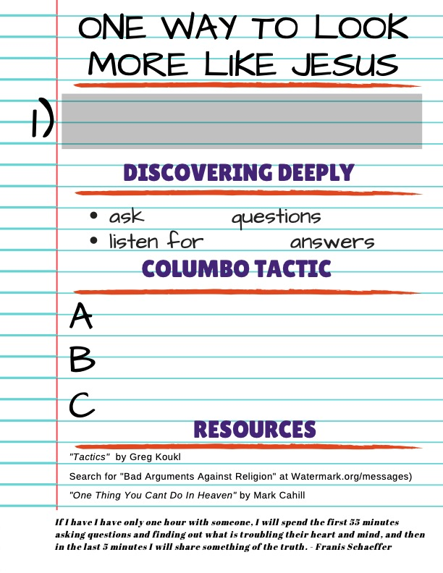

Abortion- How to Winsomely Advocate for Truth
Bruce Kendrick, Watermark’s The Life Initiative

How our Culture has shifted:
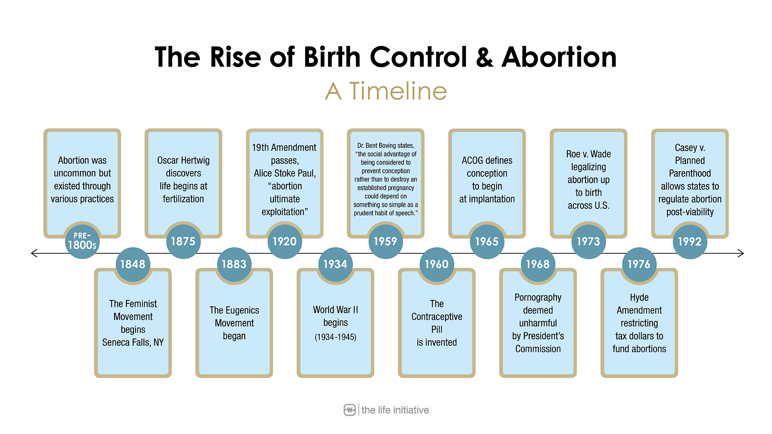

Advocating for the preborn:
S
L
E
D

Advocating for the woman:

More Resources/Further Reading:
American Association for ProLife OB/GYNs (aaplog.org)
Charlotte Lozier Institute (lozierinstitute.org)
Susan B. Anthony List (sba-list.org)
Guttmacher Institute (guttmacher.org)
Deliver Us from Abortion by Brian Fisher
The Case for Life by Scott Klusendorf
Email the Life Initiative: thelifeinitiative@watermark.org
Abortion- How to pastorally care for the affected
Mel Miller, Watermark Women’s Community

Elements in a Crisis

Your Responsibility

Pre-Abortion Minded Woman

Post Abortion Minded Woman

Philippians 2:3-8:
Do nothing out of selfish ambition or vain conceit. Rather, in humility value others above yourselves, ⁴ not looking to your own interests but each of you to the interests of the others.
In your relationships with one another, have the same mindset as Christ Jesus:
Who, being in very nature God, did not consider equality with God something to be used to his own advantage; rather, he made himself nothing by taking the very nature] of a servant, being made in human likeness.
And being found in appearance as a ma he humbled himself by becoming obedient to death—even death on a cross!
Ministering to the LGBT Community and the Same-Sex Attracted
D’Ann Davis, 16 years of ministry to same-sex attracted and gay-identified women

How did our culture get here?
- Romans 1:18-32
- Postmodernism
- Two greatest cultural virtues: The Autonomous Self & The Authentic Self
- Lost meaning of sexuality, marriage, sanctity of life, and gender
- Rejection of Biblical Masculinity & Femininity

Is someone born gay?
- No scientific or genetic study establishes a person is born gay or trans; most evidence suggests an amalgamation of factors including, environmental, developmental, biological, personality, etc.
- Sexuality is complex, particularly for women
- Gender development is key; strugglers often exhibit non-gender conforming interests (“other than”) *these personalities do not denote a same sex attracted experience, but are often present
- The Three A’s:

- Boys and Girls receive 3A’s in different ways from both parents
- A breakdown occurs that leads to misidentification with one’s own gender & an over-identification with the opposite gender; sometimes, though not always, sexual abuse is a factor
- The same gender becomes a mystery, rather than the opposite gender
- Hormones & mystery fuel attraction

Transgender
- Transgenderism often occurs when the aforementioned misidentification with one’s own gender stretches to an extreme form
- Gender Dysphoria, a mental illness
- Autogynephilia (Cross-Dressing), related, though not synonymous
- 0.3% of the population identifies as Trans
- Cisgender
- Intersex argument

How do we respond?
- 3 Categories of same-sex attracted individuals
  - Lost People
  - Christians who have embraced a gay identity
  - Christians who experience SSA but want to walk in freedom and obedience to the Scriptures
- Remind ourselves of truth:
  - People can change (1 Cor 6:9-11)
  - Operate with grace and truth (John 1:14, John 1:17)
  - We CAN relate (Romans 3:23, Romans 5:8, Galatians 5:1, Romans 7)
- Responding to pro-gay theology
  - Mark 8:34-36

- Sharing with Trans Friends
  - Romans 12:1-2

- Pray for these opportunities!
  - John 1:5, Proverbs 14:12-14, John 6:68-69

More Resources/Further Reading:
When Harry Became Sally: Responding to the Transgender Moment. – Ryan Anderson
Desires in Conflict: Hope for Men Who Struggle with Sexual Identity – Joe Dallas
The Heart of Female Same-Sex Attraction: A Comprehensive Counseling Resource – Janelle Hallman
Messy Grace – Caleb Kaltenbach
Love Thy Body: Answering Hard Questions About Life and Sexuality – Nancy Pearcey
God and the Transgender Debate: What Does the Bible Actually Say About Gender Identity? – Andrew Walker
Immigration: What it is, why it happens, and how to respond
Emmanuel Okaalet, Watermark Health Fellow
Oscar Castillo, Watermark Director of International Engagement

Why Migrate to the USA?

Nonimmigrant Admission | Refugee | Asylee | Permanent Resident | U.S. Citizen | Unauthorized Immigrant
Student visa  (valid up to 5years)  Tourist/Business visa  (validity: 1month – 10year)  Fiancé(e) visa  (validity: 6 months)  Temporary Protected  Status  (validity: 6-18months) | Apply OUTSIDE USA | Apply at Port of Entry,  OR  post entry | aka Green Card  Sponsor required: Family, or Employer | Birth  Naturalization | Overstay  Non-Immigrant  admission  Enter US without going through Port of Entry

What the Bible Says
Genesis 1:27 So God created man in his own image, in the image of God he created him;
male and female he created them.

Exodus 23:9 You shall not oppress a sojourner. You know the heart of a sojourner,
for you were sojourners in the land of Egypt.

Deuteronomy 10:18 He executes justice for the fatherless and the widow,
and loves the sojourner, giving him food and clothing.

Psalm 146:9 The Lord watches over the sojourners; he upholds the widow and the fatherless, but the way of the wicked he brings to ruin.”

Malachi 3:5 Then I will draw near to you for judgment. I will be a swift witness against the sorcerers, against the adulterers, against those who swear falsely, against those who oppress the hired worker in his wages, the widow and the fatherless, against those who thrust aside the sojourner, and do not fear me, says the Lord of hosts.

Matthew 25:35-36, 40 For I was hungry and you gave me food, I was thirsty and you gave me drink, I was a stranger and you welcomed me, I was naked and you clothed me, I was sick and you visited me, I was in prison and you came to me. And the King will answer them, ‘Truly, I say to you, as you did it to one of the least of these my brothers, you did it to me.

Hebrews 13:2 Do not neglect to show hospitality to strangers, for thereby some have entertained angels unawares.

1 Peter 1:17 And if you call on him as Father who judges impartially according to each one's deeds, conduct yourselves with fear throughout the time of your exile”
How we should care:

FYI- Modes of Acculturation
- marginalization ( dessert )- refers to losing one’s culture identity and not having a psychological construct with the larger society.
- separation or segregation (water & oil) -
  - refers to maintaining one’s original culture and not participating in the new culture.
  - connotes sense of strong racial/ethnic identity.
  - Majority of churches in America fall in this category
- assimilation (melting pot) -
  - refers to giving up one’s original cultural identity and moving into full participation in the new culture.
  - the person identifies with the country and not with their ethnic group.
  - long-term, multigenerational process.
  - small percentage of churches who operate under the assimilation model sometimes offer: ESL classes, citizenship classes, computer classes, and other courses to teach American cultural values and norms.
- integration ( salad bowl ) -
  - refers to maintaining important aspects of one’s original culture as well as becoming an integral part of the new culture.
  - ensures a continuity of culture.
  - the person feels loyal to the country as to his/her ethnic group.
  - churches who operate under the integration model are a rare find, so there is an opportunity to innovate
- incubation -
  - refers to hosting a particular people group with the purpose of launching their own effort.
  - short-term process with a defined timeline
  - long-term relationship with mentorship
  - host churches that have tried incubation tend to host but not foment a relationship with church leaders of the ethnic church

Resources/References/Further Reading:
The Bible by God (through 40 different authors)
Seeking Refuge: On the Shores of the Global Refugee Crisis by Stephen Bauman
Christians at the Border: Immigration, the Church, and the Bible by Dr. Daniel Carroll
Welcoming the Stranger: Justice, Compassion & Truth in the Immigration Debate by Matthew Soerens
https://usafacts.org/reports/immigration
https://www.apa.org/topics/immigration/undocumented-video
https://www.citylab.com/equity/2019/07/immigration-ice-raids-deportation-fear-migrant-families/594532/
https://www.nolo.com/legal-encyclopedia/if-someone-tips-ice-off-i-m-illegally-the-us-will-i-deported.html
https://www.dhs.gov/immigration-statistics/yearbook/2017#*
https://www.pewresearch.org/fact-tank/2019/06/12/us-unauthorized-immigrant-population-2017/
Panel- How do we apply this?
Moderator- Christy Chermak, Watermark Health Executive Director
Paige Heard, Skillman Clinic Charge Nurse
Sam Victor, Skillman Clinic Charge Nurse
Katy Vogelaar, Skillman Clinic Provider

